Traditional exam style questions on Covalent bonding

- The electronegativities of four different elements are given below (the letters are not their chemical symbols).
Element | W | X | Y | Z
Electronegativity | 0.9 | 1.2 | 3.4 | 4.0
Based on this information which statement is correct?
- W is a non-metal.
  - W and X form an ionic compound.
  - Y is a metal.
  - Y and Z form a covalent compound.
(Total 1 mark)
- Which is the best description of the bonding present in the ammonium ion, NH₄⁺?
  - Sharing of electrons between atoms
  - Electrostatic attraction between ions
  - Electrostatic attraction between positive ions and delocalized electrons
  - Sharing of electrons between atoms and electrostatic attraction between ions
(Total 1 mark)

- Which compound forms hydrogen bonds in the liquid state?

  - C₂H₅OH
  - CHCl₃
  - CH₃CHO
  - (CH₃CH₂)₃N

(Total 1 mark)

- What is the correct Lewis structure for hypochlorous acid, a compound containing chlorine, hydrogen and oxygen?

(Total 1 mark)
- How do the bond angles in CH₄, NH₃ and H₂O compare?

  - CH₄ = NH₃ = H₂O
  - CH₄ < NH₃ < H₂O
  - NH₃ < CH₄ < H₂O
  - H₂O < NH₃ < CH₄

(Total 1 mark)
- The Lewis structure of SO₂ is given below.
What is the shape of the SO₂ molecule?

  - Bent (V-shaped)
  - Linear
  - T-shaped
  - Triangular planar

(Total 1 mark)

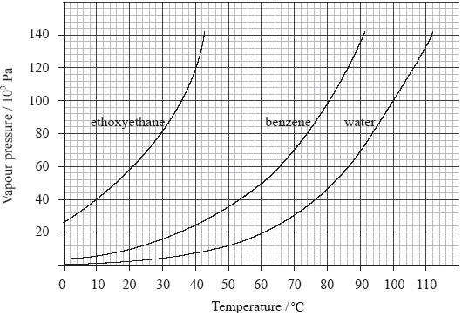
- The graph below illustrates how the vapour pressures of ethoxyethane, CH₃CH₂OCH₂CH₃, benzene, C₆H₆, and water, H₂O, change with temperature.

  - Using data from the graph, explain the difference in vapour pressure of ethoxyethane, benzene and water at 30 °C.
......................................................................................................................................
......................................................................................................................................
......................................................................................................................................
......................................................................................................................................
......................................................................................................................................
......................................................................................................................................
......................................................................................................................................
......................................................................................................................................
......................................................................................................................................
(4)

  - Use the graph to determine the boiling point of benzene at standard pressure.
......................................................................................................................................
(1)
(Total 5 marks)
- Which molecule has a non-bonding (lone) pair of electrons on the central atom?

  - BF₃
  - SO₂
  - CO₂
  - SiF₄

(Total 1 mark)
- The number of electrons in the valence shell of elements A and B, are 6 and 7 respectively. What is the formula and type of bonding in a compound formed by these elements?

  - A₂B, covalent
  - AB₂, covalent
  - A₂B, ionic
  - AB₂, ionic

(Total 1 mark)
- Which order is correct when the following compounds are arranged in order of increasing melting point?

  - CH₄ < H₂S < H₂O
  - H₂S < H₂O < CH₄
  - CH₄ < H₂O < H₂S
  - H₂S < CH₄ < H₂O

(Total 1 mark)

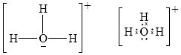
- Lewis structures are represented in different ways in different parts of the world. Two ways of drawing the Lewis structure for H₃O⁺ are shown below.

Which statement is correct about H₃O⁺? A. The ion has a tetrahedral shape.
  - The H–O–H bond angle is 120°.
  - The H–O–H bond angle is 90°.
  - The ion has a trigonal pyramidal shape.
(Total 1 mark)

- Which substance can form intermolecular hydrogen bonds in the liquid state?

  - CH₃OCH₃
  - CH₃CH₂OH
  - CH₃CHO
  - CH₃CH₂CH₃

(Total 1 mark)

- Which pair of compounds is arranged in correct order of relative boiling points?
Lower Boiling Point | Higher Boiling Point
CH₃OCH₃ | CH₃CH₂OH
CH₃CHO | CH₃CH₂CH₃
CH₃CH₂OH | CH₃CHO
CH₃COOH | CH₃CH₂OH
A.
B.
C.
D.

(Total 1 mark)
- What is the shape of the ammonia molecule, NH₃?

  - Trigonal planar
  - Trigonal pyramidal
  - Linear
  - V-shaped (bent)

(Total 1 mark)
- Which pair of compounds is arranged in correct order of relative boiling points?
Lower Boiling Point | Higher Boiling Point
H₂S | H₂O
NH₃ | PH₃
HF | HCl
CH₃COOH | CH₃CH₂OH
A.
B.
C.
D.

(Total 1 mark)

- Methoxymethane, CH₃OCH₃, and ethanol, C₂H₅OH, have the same relative molecular mass. Explain why methoxymethane has a much lower boiling point than ethanol.
................................................................................................................................................
................................................................................................................................................
................................................................................................................................................
................................................................................................................................................
................................................................................................................................................
(Total 3 marks)

- Which molecule is polar?
  - CH₂Cl₂
  - BCl₃
  - Cl₂
  - CCl₄
(Total 1 mark)
- Which combination of intermolecular forces, boiling point and enthalpy of vaporization is correct?
Intermolecular forces | Boiling point | Enthalpy of vaporization
strong | low | low
strong | high | low
weak | low | high
weak | low | low
A.
B.
C.
D.

(Total 1 mark)

- The graph below shows the boiling points of the hydrides of group 5. Discuss the variation in the boiling points.
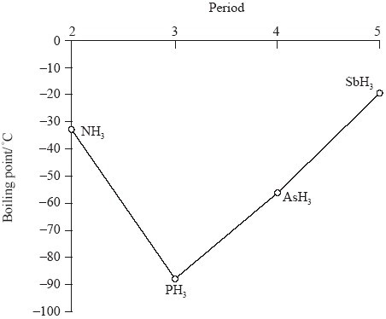

(Total 4 marks)

